11 September Results Draft Outline

3. Results
All results from linear models still working on it, but it seems like distance and z star are significant across models, and differences in marsh edge typology are approaching significance with a p value ~0.07. Would need more data to test mechanism.

3.1 Sediment Deposition Across Ramped and Scarped Marsh Edges

Across Space

Distance from Marsh Edge
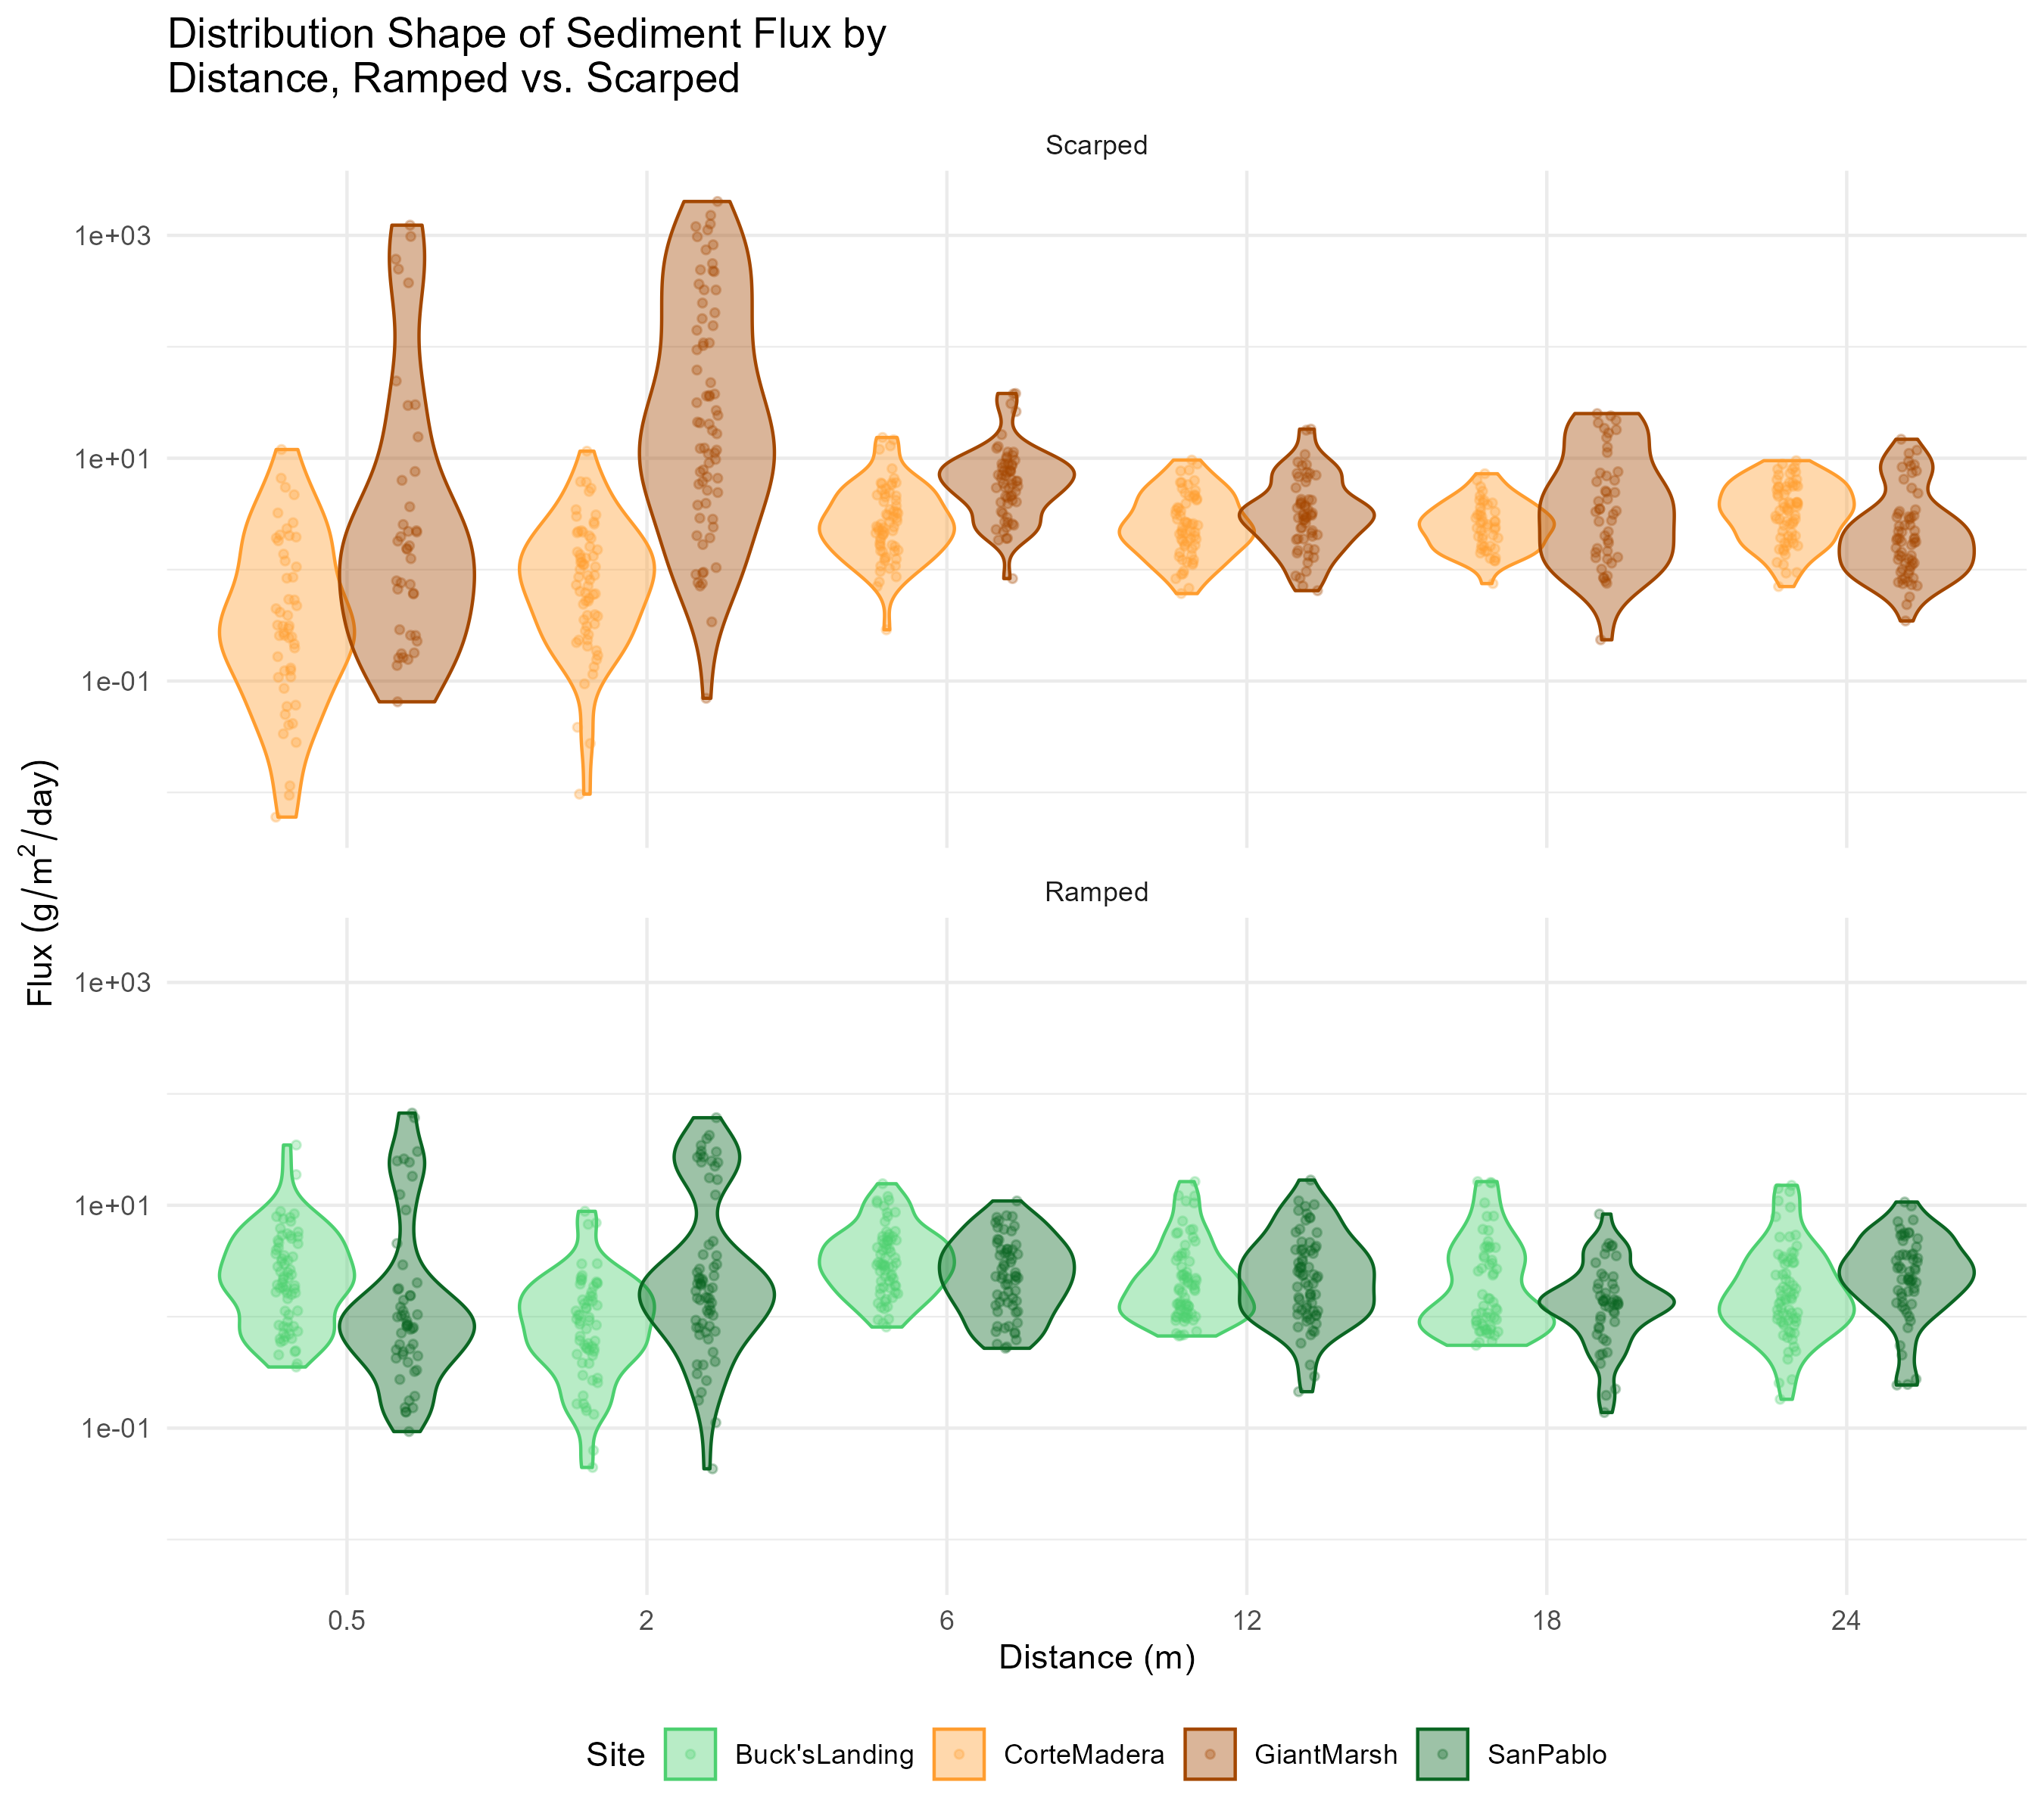

Relative Elevation with Tidal Inundation (z*)
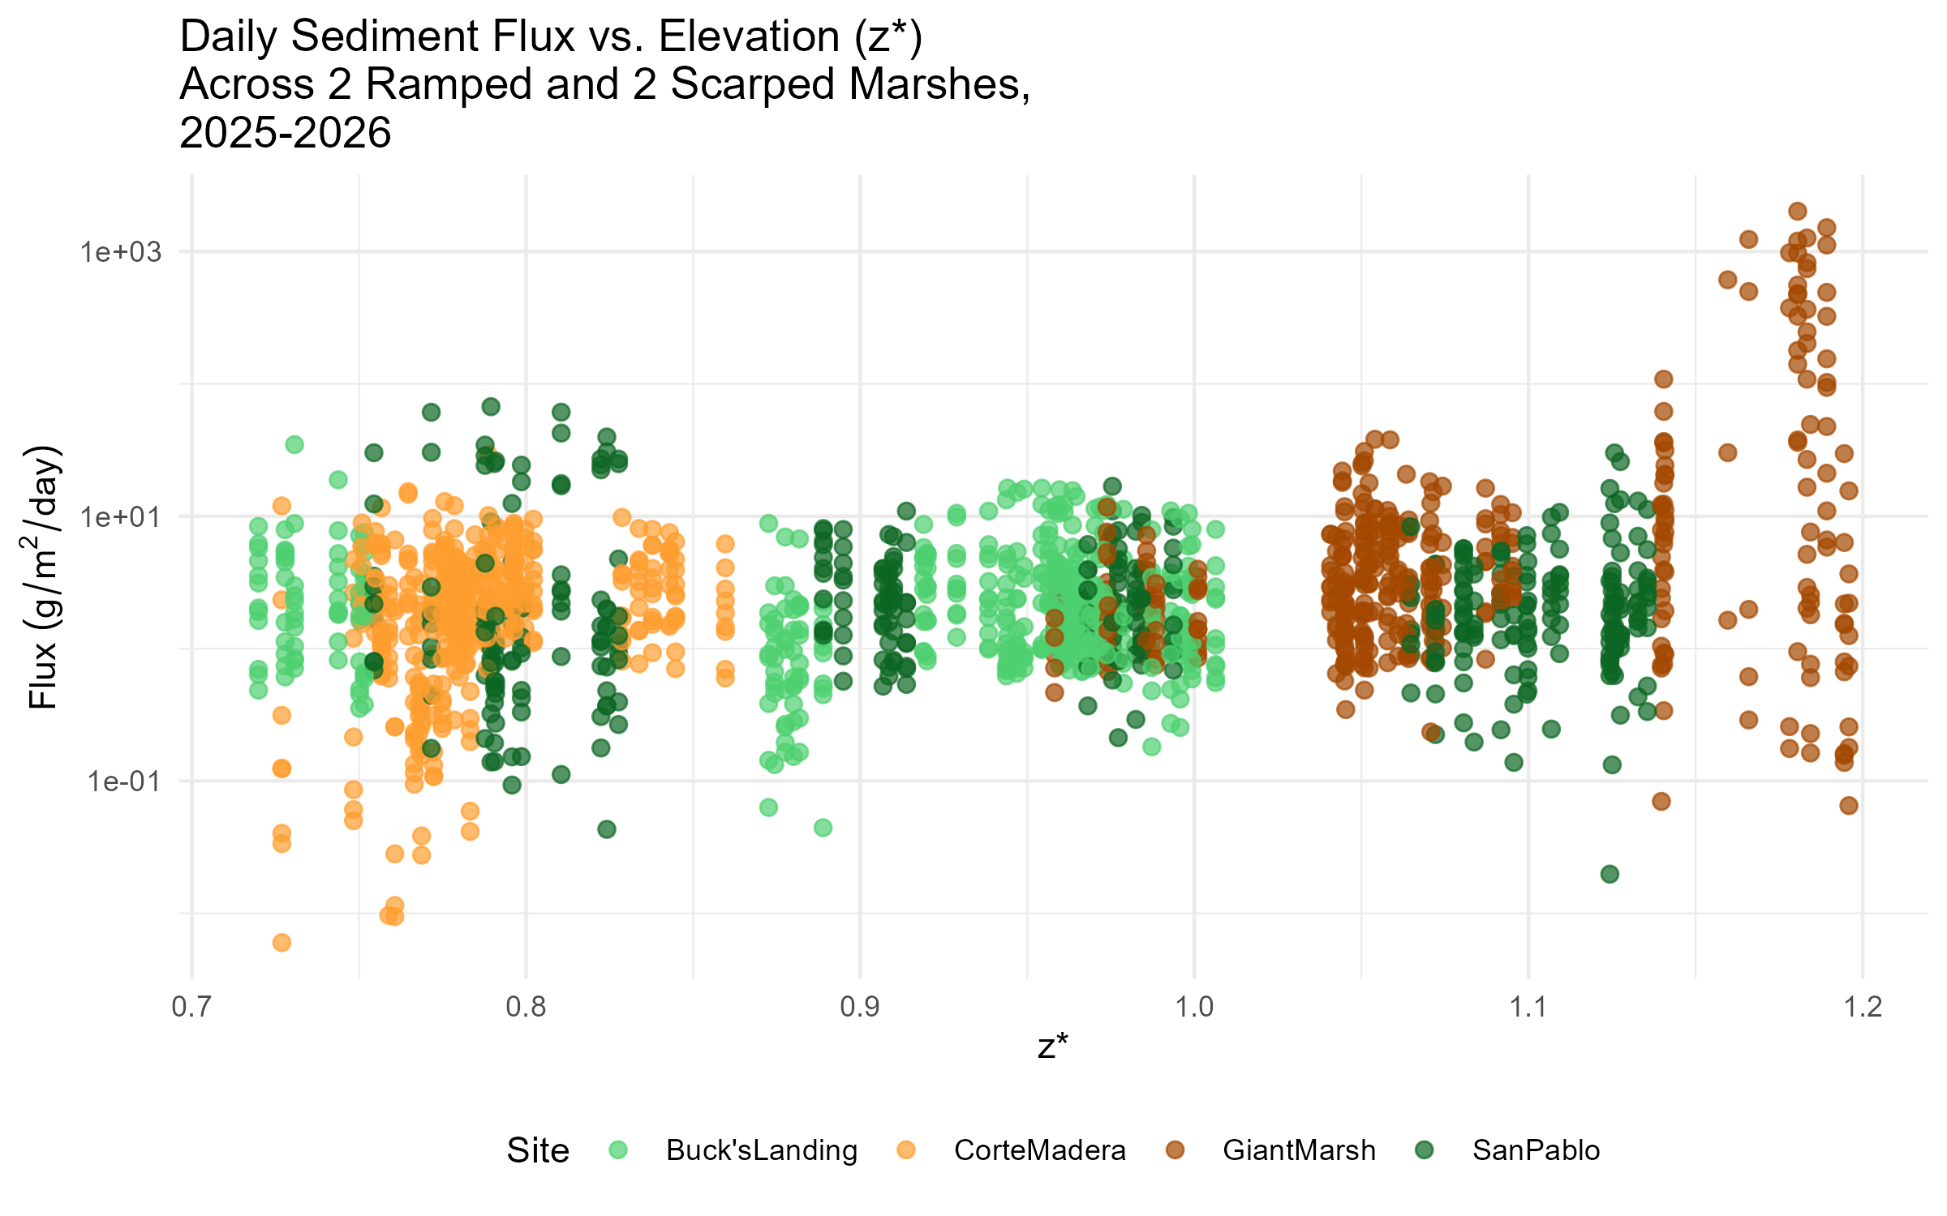

Across Time

Per Month (Need to Confirm Timing)
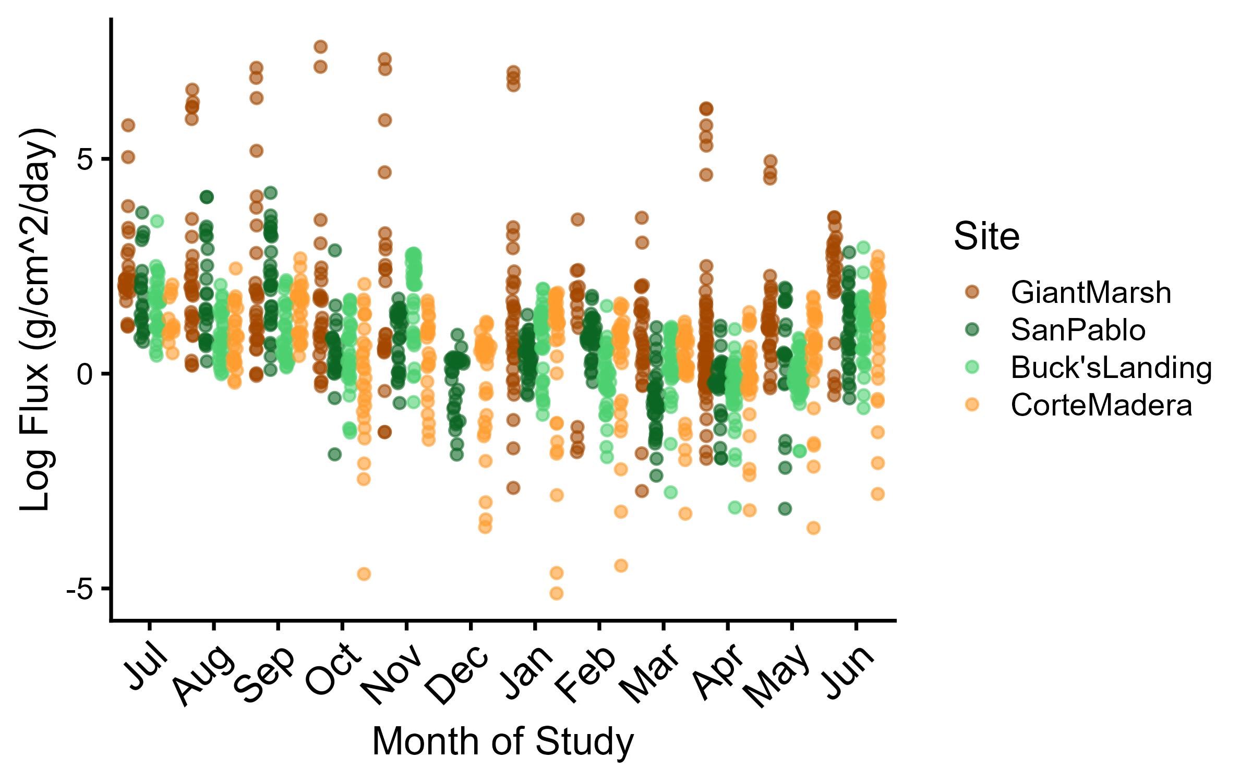

Phenological and Seasonal (Working on It-Will Decide Very Soon)

Main Takeaway Result to Close Out Results/Discussion for Future Work-Skewness!
